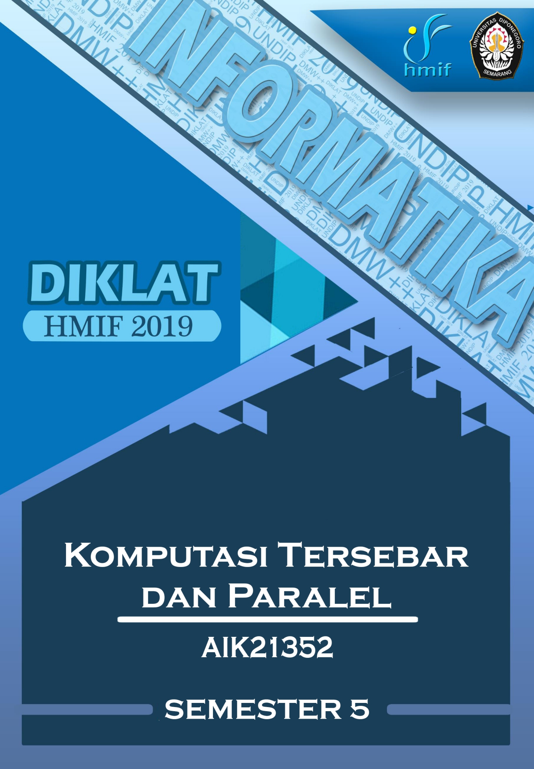

**DAFTAR ISI**

DAFTAR ISI 2

SOAL UJIAN TENGAH SEMESTER 2014/2015 3

SOAL UJIAN AKHIR SEMESTER 2014/2015 4

SOAL UJIAN TENGAH SEMESTER 2017/2018 5

SOAL UJIAN AKHIR SEMESTER 2017/2018 6

SOAL UJIAN TENGAH SEMESTER 2018/2019..................................................... 7

|  |  |
| --- | --- |
| Database Soal Sistem Terdistribusi | AIK21352 |

SOAL UJIAN TENGAH SEMESTER 2014/2015

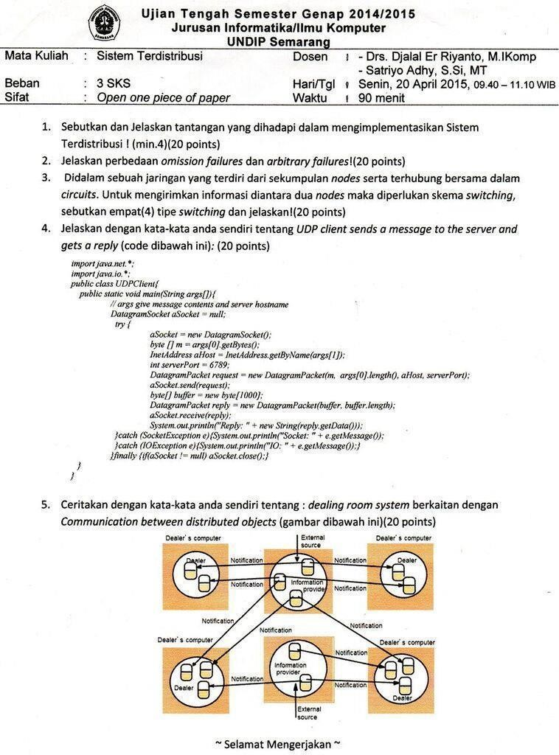

|  |  |
| --- | --- |
| Database Soal Sistem Terdistribusi | AIK21352 |

SOAL UJIAN AKHIR SEMESTER 2014/2015

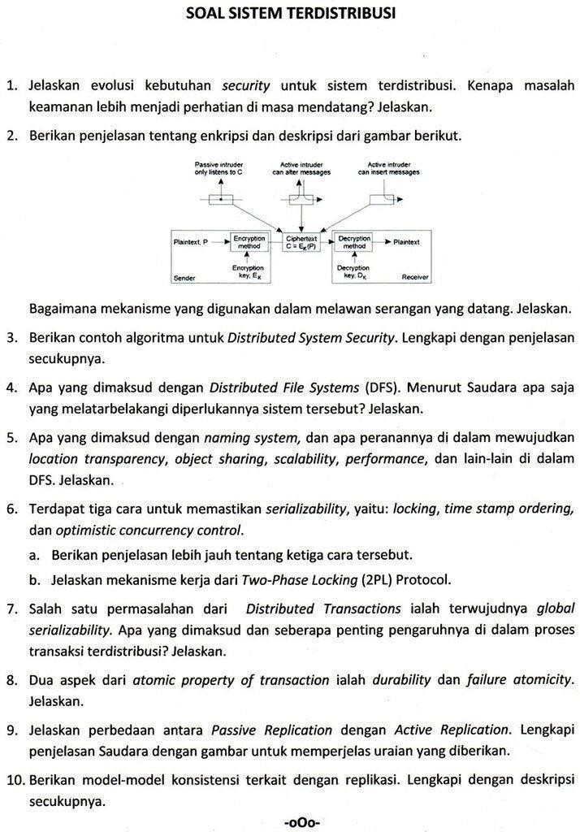

|  |  |
| --- | --- |
| Database Soal Sistem Terdistribusi | AIK21352 |

SOAL UJIAN TENGAH SEMESTER 2017/2018

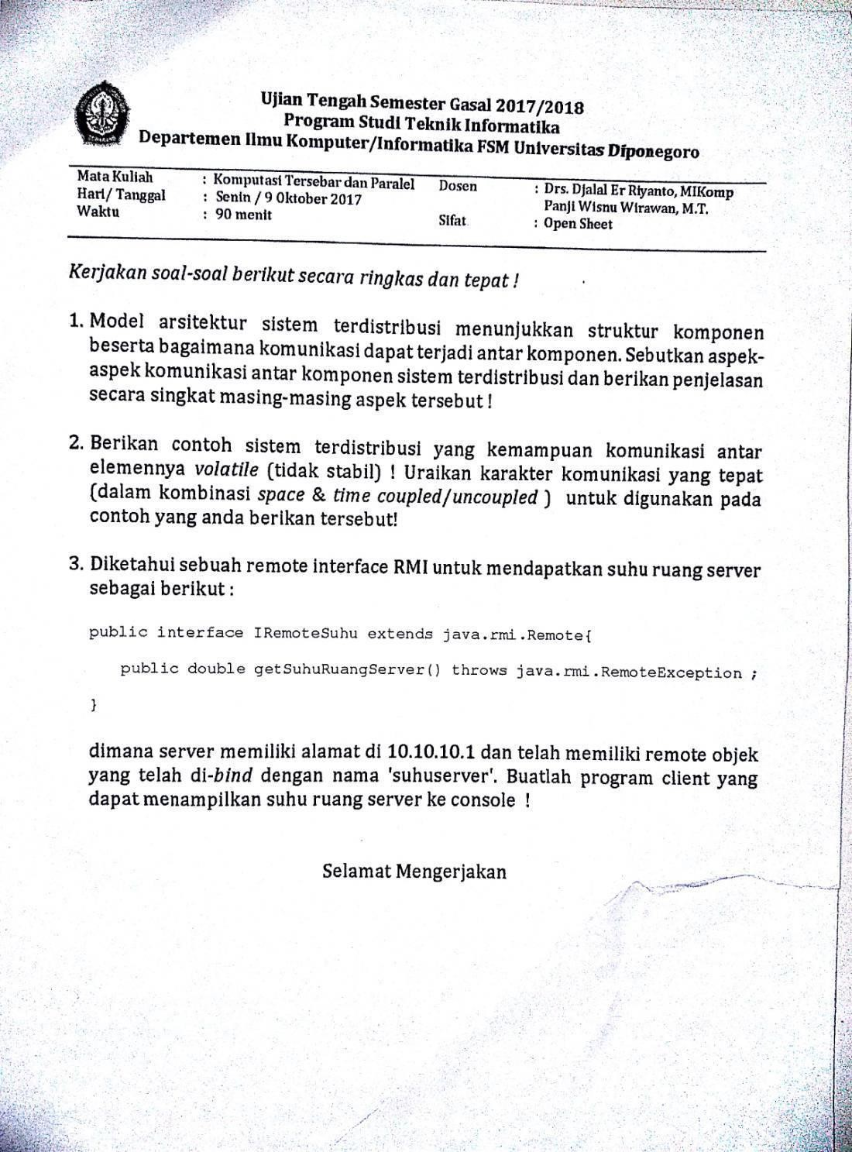

|  |  |
| --- | --- |
| Database Soal Sistem Terdistribusi | AIK21352 |

SOAL UJIAN AKHIR SEMESTER 2017/2018

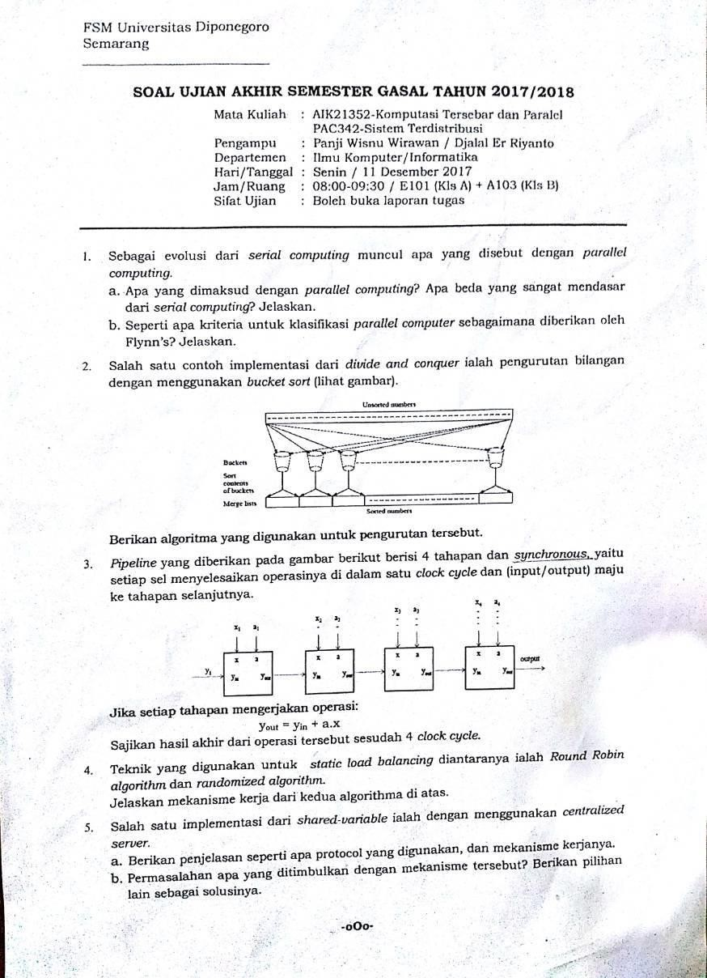

|  |  |
| --- | --- |
| Database Soal Sistem Terdistribusi | AIK21352 |

**UJIAN TENGAH SEMESTER 2018/2019**

